Robotics
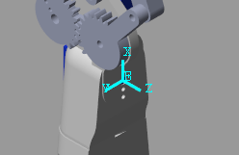
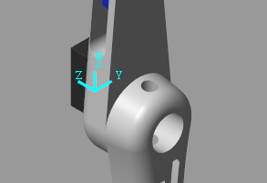
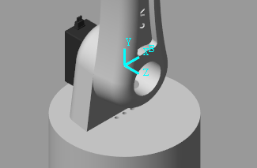
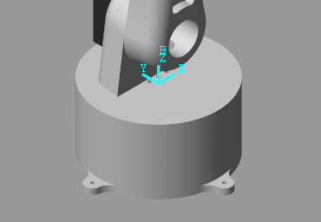
Team 14
Figure 4 Frame 3
Figure 3 Frame 2
Figure 2 Frame 1
Figure 1 Frame 0

Frame 4 is found at the E.E
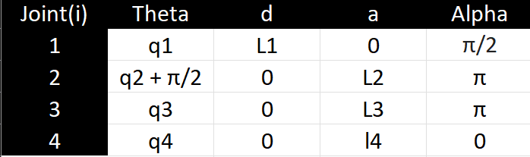
D-H Convention Table
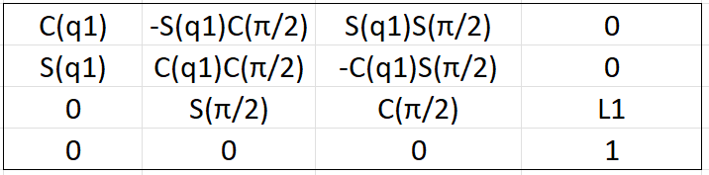
⁰T₁ =

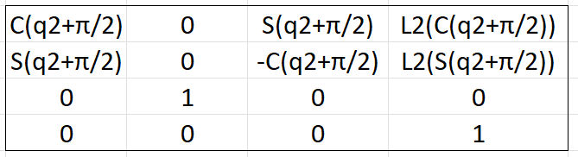
¹T₂ =

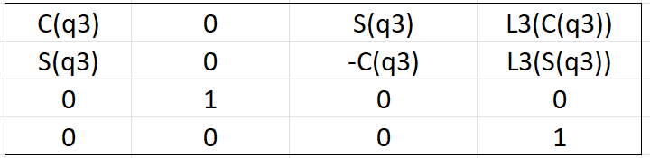
²T₃ =

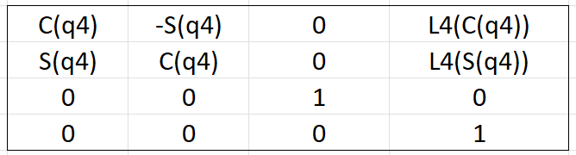
³T₄ =

⁰T₄ = ⁰T_{1 *} ¹T_{2 *} ²T_{3 *} ³T₄
The Scripts for both MATLab and Python are included in the Scripts folder as well as some tested values are shown in the videos provided. Since each software, Gazebo and Simscape, were tracking slightly different points on the End Effector, the output values varied slightly yet were still almost identical with a slight offset that doesn’t change. The inputs yielded a physically possible orientation of the robot within its physical constraints which are based on the range of the servo motors (180).
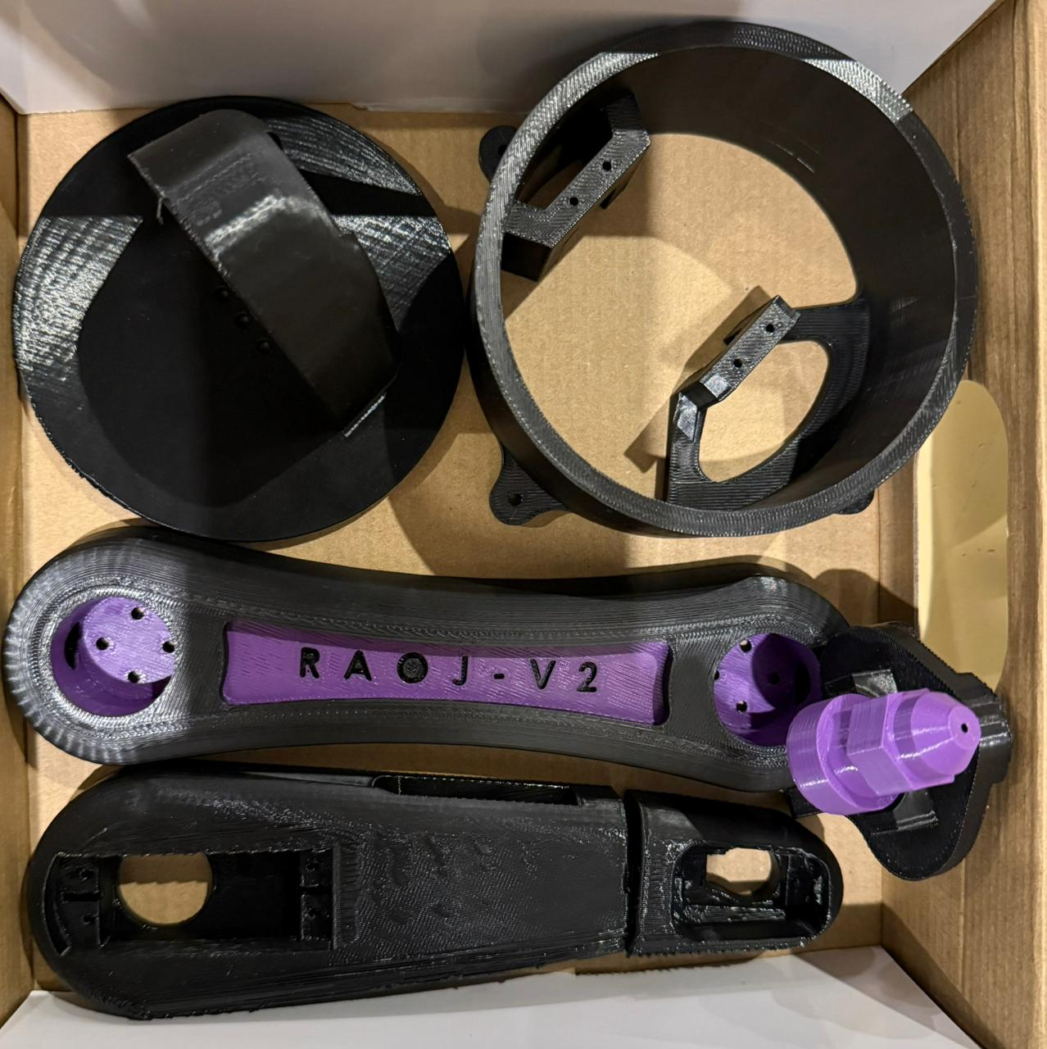
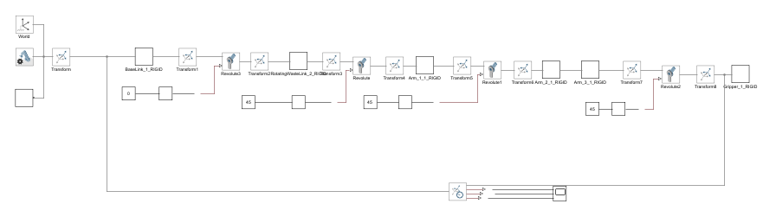

Inverse Position Kinematics
Inverse Position Kinematics is the process of determining the joint angles required for a robot’s end effector to reach a specific position and orientation in space. It solves the mathematical relationship between the robot’s geometry and its desired pose, enabling precise motion control. The objective for the 5-DOF all-revolute manipulator is to compute joint variables q = [q₁, q₂, q₃, q₄, q₅]ᵀ that achieve a desired 5-dimensional task vector Xᵈ.
X(q) = [x(q), y(q), z(q)]ᵀ

Task-Space Representation
X(q) = [ x(q), y(q), z(q) ]ᵀ
where x(q), y(q), z(q) are extracted from T⁰₅(q)

Nonlinear Equation
We rewrite the inverse kinematics as a system of nonlinear equations in terms of an error function F(q):
F(q) = X(q) − Xᵈ = 0
In components, this is:
F₁(q) = x(q) − xᵈ = 0
F₂(q) = y(q) − yᵈ = 0
F₃(q) = z(q) − zᵈ = 0
Jacobian Construction
Like the scalar Newton–Raphson method, we seek a root of F(q) = 0 by iteratively improving an initial guess q⁰. For a vector-valued function F, the Newton–Raphson update is:
qᵏ⁺¹ = qᵏ − J(qᵏ)⁻¹ F(qᵏ)
where J(q) is the Jacobian (3×5) of F(q):
J(q) = ∂F/∂q = ∂X/∂q =
[ ∂x/∂q₁ ∂x/∂q₂ ∂x/∂q₃ ∂x/∂q₄ ∂x/∂q₅ ]
[ ∂y/∂q₁ ∂y/∂q₂ ∂y/∂q₃ ∂y/∂q₄ ∂y/∂q₅ ]
[ ∂z/∂q₁ ∂z/∂q₂ ∂z/∂q₃ ∂z/∂q₄ ∂z/∂q₅ ]

For each revolute joint i with axis zᵢ₋₁ and origin pᵢ₋₁ (expressed in the base frame):
Jᵥ,ᵢ = zᵢ₋₁ × (O₅ − Oᵢ₋₁)
Jω,ᵢ = zᵢ₋₁

Newton–Raphson Iteration
Given estimate qᵏ, the Newton–Raphson update proceeds:
1) Compute X(qᵏ)
2) eᵏ = X(qᵏ) − Xᵈ
3) Compute J(qᵏ)
4) Solve J(qᵏ) Δqᵏ = −eᵏ
5) Update qᵏ⁺¹ = qᵏ + Δqᵏ
Compact Formula
qᵏ⁺¹ = qᵏ − J(qᵏ)⁻¹ ( X(qᵏ) − Xᵈ )

Forward Velocity Kinematics
Forward velocity kinematics describe how joint velocities map to end-effector linear and angular velocities. For a 5-DOF all-revolute manipulator, the task-space velocity vector is:
Ẋ = [V​x V​y V​z ωx ​ωy ​ωz]​​​ᵀ =J(q)q˙​
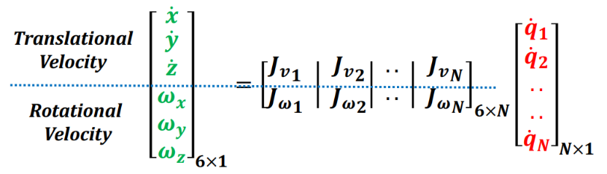

The main mapping is:
Ẋ = J(q) q̇

Each column of the geometric Jacobian for revolute joint i is constructed using:
Jv,i = zᵢ₋₁ × (Oₑₑ − Oᵢ₋₁)
Jω,i = zᵢ₋₁
A 5×6 selection matrix S extracts the desired five task components, forming the 5×5 Jacobian:
J(q) = S J_geo(q)
For a planar 5-R robot with link lengths L₁…L₅ and joint angles q₁…q₅, the end-effector position is:
Xₑₑ = Σ Lₖ cos(Φₖ)
Yₑₑ = Σ Lₖ sin(Φₖ)
where Φₖ = q₁ + q₂ + … + qₖ.
Differentiation gives the forward velocity:
Ẋₑₑ = Σ [-Lₖ sin(Φₖ) Σ_{j=1→k} q̇ⱼ]
Ẏₑₑ = Σ [ Lₖ cos(Φₖ) Σ_{j=1→k} q̇ⱼ]
The Jacobian for the planar arm is 2×5, with partial derivatives:
Jxj = ∂Xₑₑ/∂qⱼ = - Σ_{k=j→5} Lₖ sin(Φₖ)
Jyj = ∂Yₑₑ/∂qⱼ = Σ_{k=j→5} Lₖ cos(Φₖ)

Inverse Velocity Kinematics
Since the planar robot has only two task-space velocity components but five joints, it is redundant. The pseudoinverse provides one valid solution:
q̇ = J⁺ [Ẋₑₑ, Ẏₑₑ]ᵀ

Hardware Assembly
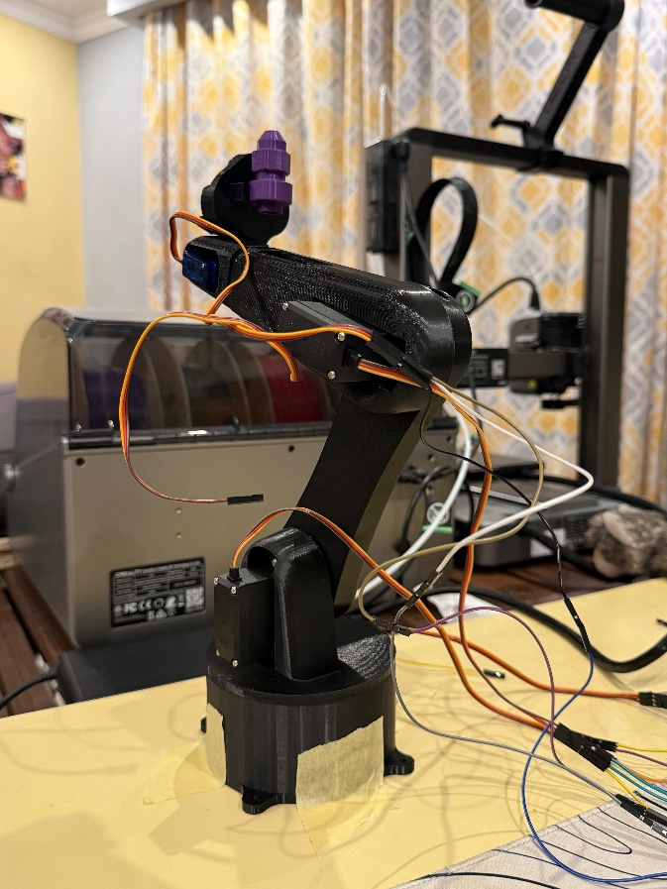
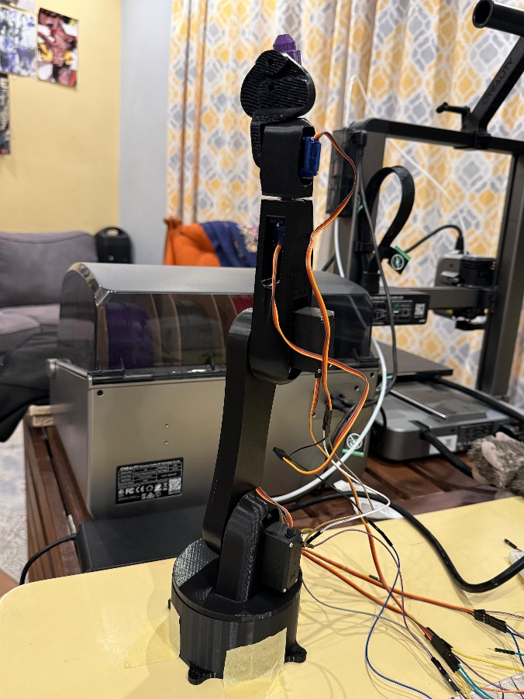
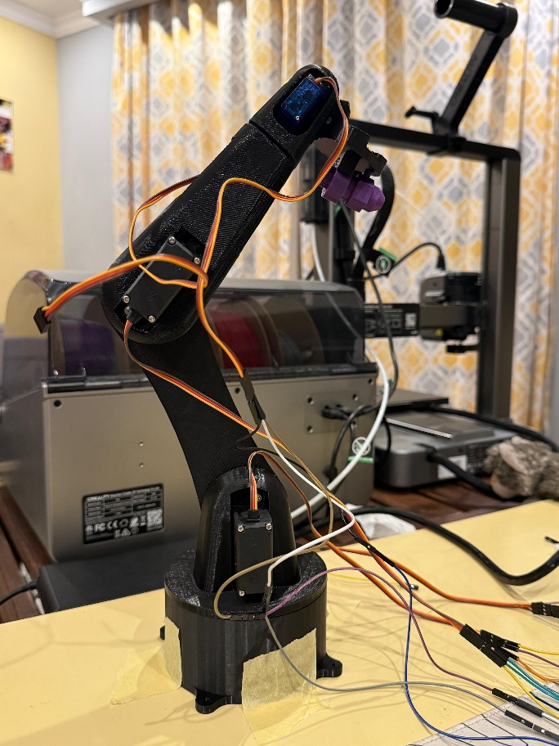

  - Due to some limitation in the assembly of the hardware and the high ampere demand of the motors, we could not test its overall movement. However, each motor works on its own an until a better way to supply power to the motors, open loop testing is not possible.

Developed Trajectories Equations
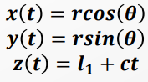


  - These are the equations used to formulate our semi-circular paths.
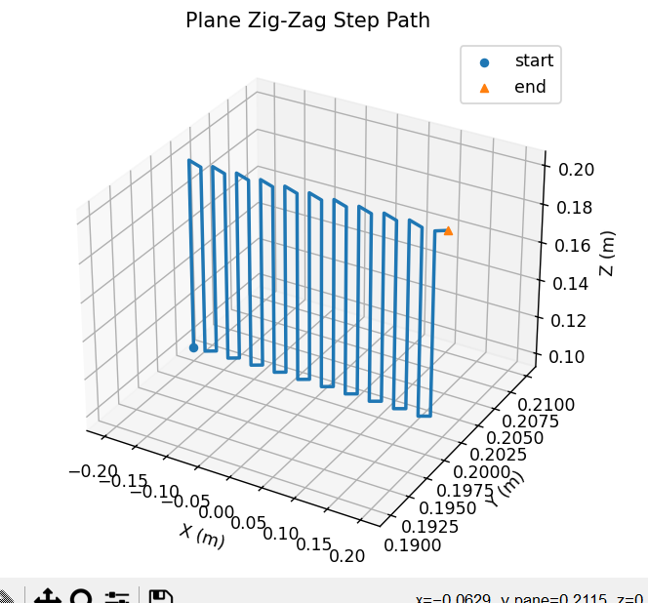

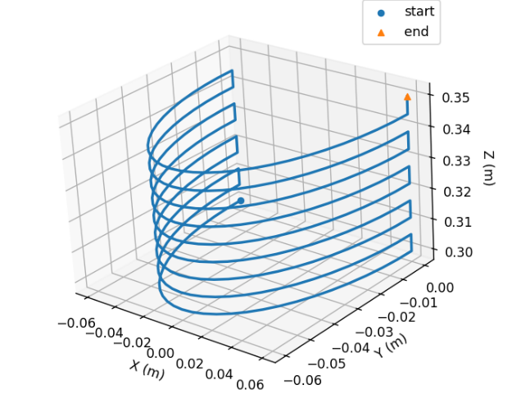
  - This is our first path where the robotic arm follows a planar surface, ensuring our sanitizing nozzle is able to reach all the points on a wall for instance.

  - This is our second path where the robotic arm follows some sort of curved shape around itself for sanitizing the inside of hazardous materials barrels for instance.

